PriceComp
(A Marketplace Product Price Comparator App)

User Manual
Team Name: S.E.N.D.
Project Title: Marketplace Product Price Comparator App
Course: CIS 553 - 002, Fall 2022
Group Members: Nayan Patel, Steve Anderau, Ethan Pellegrini, Dheeraj Mohanbabu

Version Info:
Version No. | Date | Description of Changes | Approver
1.0 | 11/27/2022 | Initial Draft | S.E.N.D. Team
1.1 | 11/30/2022 | Added section 2.2 and 2.3 contents | S.E.N.D. Team
1.2 | 12/06/2022 | Added the additional features | S.E.N.D. Team
1.3 | 12/06/2022 | Screenshots of main and additional functionality | S.E.N.D. Team
1.4 | 12/08/2022 | Added the main scenario | S.E.N.D. Team

Table of Contents

1 System Overview 3
2 Installation Guide 3
2.1 User Prerequisites 3
2.2 Programming Platform and Operating System 4
2.3 List of Libraries 4
2.4 Extracting .zip file 5
2.5 User Configurations 6
1. Chrome Browser and Chrome Driver 6
2. Update My User Agent 6
2.6 Common Issues and Limitations 7
2.7 Executing the System 8
3 Main Functionalities 8
3.1 Search Product 8
3.2 Display Product Data 9
4 Main Scenario 10
5 Additional Functionality 12
5.1 Select Marketplace Sites 12
5.2 Sort Search Results 13
6 Contacts for Troubleshooting 15

System Overview
In the world of today, when the eCommerce business is growing exponentially, more and more choices are made available to the consumer for buying a product from different online marketplace sites. amazon.com, walmart.com, bestbuy.com, target.com etc. are some of the major marketplace sites to buy products reliably and with peace of mind. These marketplace sites are offering a variety of products and also providing options to buy directly from them or their vendors.
The side effect of this is that more choices of marketplace make consumer’s product searching journey very time consuming and decision-making process tiresome. The PriceComp App is designed to make the product search and marketplace choice very easy. It provides a comprehensive platform to search the product across different marketplace sites with a single click. It lists out the search results (product name, marketplace site, product price, rating) in a tabular format, so it becomes very easy for a consumer to make a decision where to buy the product from based on price or rating factors.
The app also allows the consumer to make a selection of marketplace sites, so they can search the product from only selective marketplace sites only. Importantly, this app provides a feature to sort the results based on some sorting criteria (e.g., price low to high, price high to low, rating low to high and rating high to low).

Installation Guide

User Prerequisites
It is recommended to have basic knowledge of Python to work on this system but it is not necessary. The following section provides a step-by-step guide to install this system on the Python platform.

Programming Platform and Operating System
Python version 3.10 and higher would be required. The installation for 3.10 is found here: https://www.python.org/downloads/release/python-3100/. Refer https://www.python.org/ftp/python/3.10.0/python3100.chm for installation guide to install this version.
The Python 3.x version works on Windows, Linux and iOS operating system platforms. NOTE: This system is developed and tested for the Windows platform and it should work on other OS platforms as well but no such guarantee is provided.
Make sure to add the Python executable path to the user environment variable. See the instructions here: https://realpython.com/add-python-to-path/

List of Libraries
Following Python modules are required to be installed. Make sure that these libraries are compatible with version 3.2 of Python installation.
Library name | Installer Files and Documentation
selenium | https://selenium-python.readthedocs.io/installation.html
BeautifulSoup | https://pypi.org/project/beautifulsoup4/
tkinter | https://docs.python.org/3/library/tkinter.html
PIL (Python Imaging Library) | https://pillow.readthedocs.io/en/stable/installation.html
pandas | https://pandas.pydata.org/docs/getting_started/install.html
requests | https://pypi.org/project/requests/

Follow the instructions provided in the documentation page of each package to add that to your Python installation.

Extracting .zip file
The supplied .zip file (i.e., send.zip) can be extracted to any folder on your computer. Make sure that you do not have only READ access to that folder, otherwise running the app code will not work.
Once extracting the zip file, you will see following folders and files:
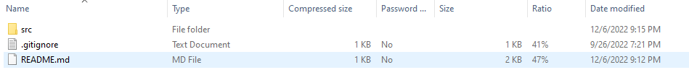
The README.md file is for the chromedriver download and installation instructions. The “src” folder contains following folders and files:
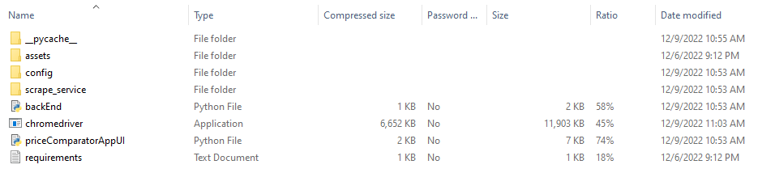
The “PriceComparatorAppUI.py” is the file containing the app frontend code whereas the “backEnd.py” file contains the backend code. The webscraping backend code can be found under “scrape_service” folder:
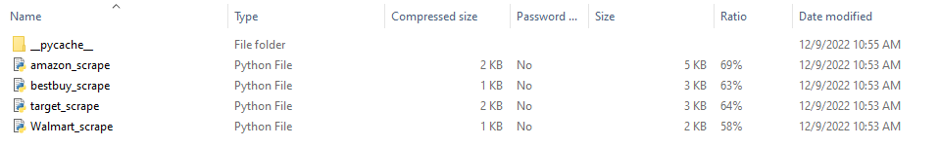
The logo images of the marketplace can be found under “assets” folder: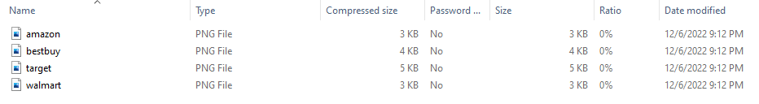
The user specific configurations have to be done in header.json file which is located under “config” folder:

User Configurations
Following user configurations are required to make the PriceComp app functional. Without these user configurations, there is a fair amount of chances that the app may not work and it will return some error while compiling.

Chrome Browser and Chrome Driver
The user needs to install the Chrome Browser suitable to their computer system. Once the Chrome Browser is installed and working properly, the compatible version of Chrome Driver (i.e., chromedriver.exe) shall need to be downloaded and placed in the same folder as the priceComparatorAppUI.py file and backEnd.py file. The Chrome Driver can be found here on this site: https://chromedriver.chromium.org/downloads
For detailed instructions, refer to https://bitbucket.org/uofm_cis/send/src/master/README.md

Update My User Agent
The file config/headers.json contains the User Agent which is specific to the computer where this system is installed. The line looks something like this:
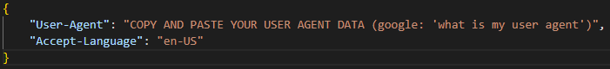
Replace the myUserAgent with your computer (and browser) specific settings. To find them, run “my user agent” in google.com from your browser and the value will be displayed like following:
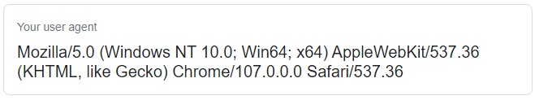
If this step is not executed and you attempt to run the application, the following error will be present in the terminal:

Common Issues and Limitations
Following common issues and limitations are known at this time:
- Keyword Search Results Not Accurate
The keyword or SKU search returns which many times do not contain the accurate product that the user is looking for. It often contains the data from a similar product or brand or sometimes accessories of the product.
- Walmart.com scraping not working
The anti-spam systems installed on the walmart.com site along with IP tracking and blocking would block the access of web scrapers on the site. The anti-spam systems installed on the site along with IP tracking and blocking would block the access of web scrapers on the site. Hence, it makes it impossible to run code to scrape the product data from walmart.com marketplace and selecting walmart from options will return no data.
- Mandatory selection of marketplace sites
The selection of marketplace site(s) is mandatory. If all the checkboxes are left unchecked, the app will not perform a search after selecting the search button.

Executing the System
In Windows, the system is currently executed using an Integrated Development Environment (IDE). All that is needed is that the user opens the priceComparatorAppUI.py file with their IDE of choice and clicks the “Run” button. If everything is installed properly, then the system will run.
Ubuntu requires a slightly different approach. Once the user adjusts the paths to work with their system and installs all of the dependencies, they need to do the following:
- Open Terminal- Right click the src folder and select Open in Terminal
- Type “python3 priceComparatorAppUI.py” into the terminal and hit Enter.
- The application UI will then launch.

Main Functionalities
The PriceComp app is offering two main functionalities: 1) Search Product and 2) Display Product Data

Search Product
The main feature of the PriceComp app is to search the product on different marketplace sites (amzon.com, bestbuy.com, walmart.com and target.com) and compare the product data (e.g., price, rating) that was retrieved from those marketplaces. For searching a product, the app has a text box on the top where the user can enter a keyword or exact SKU number of a product. See the example below: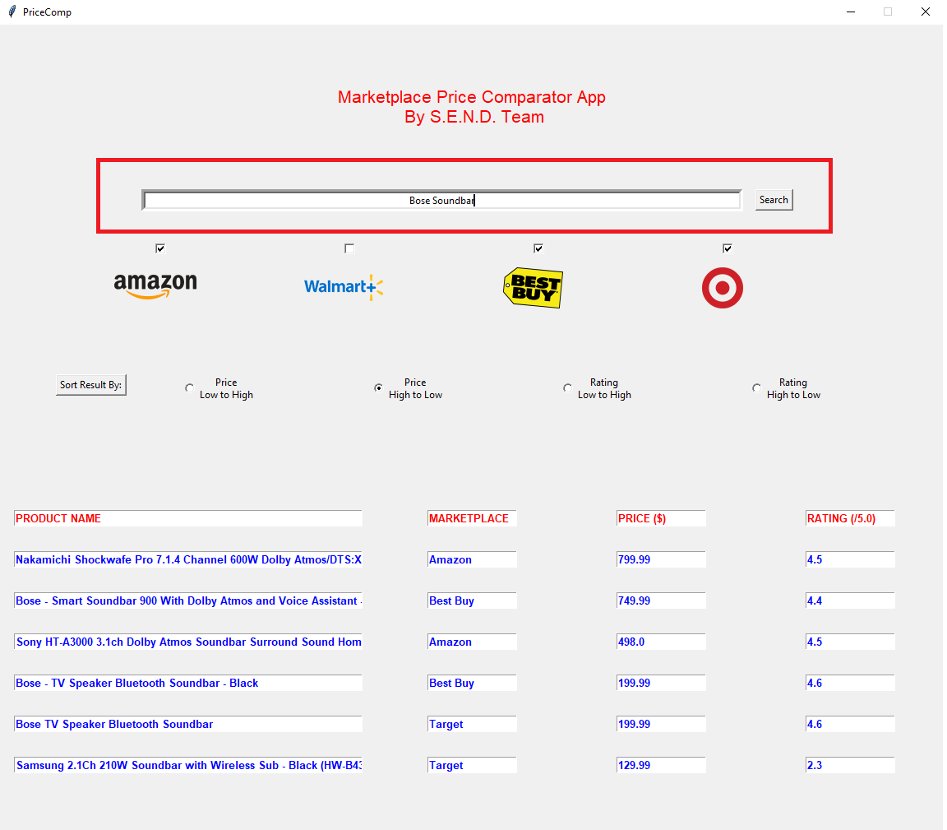

Display Product Data
This user input will be searched across the selected marketplace sites and the scraped product data will be displayed. See the example below:
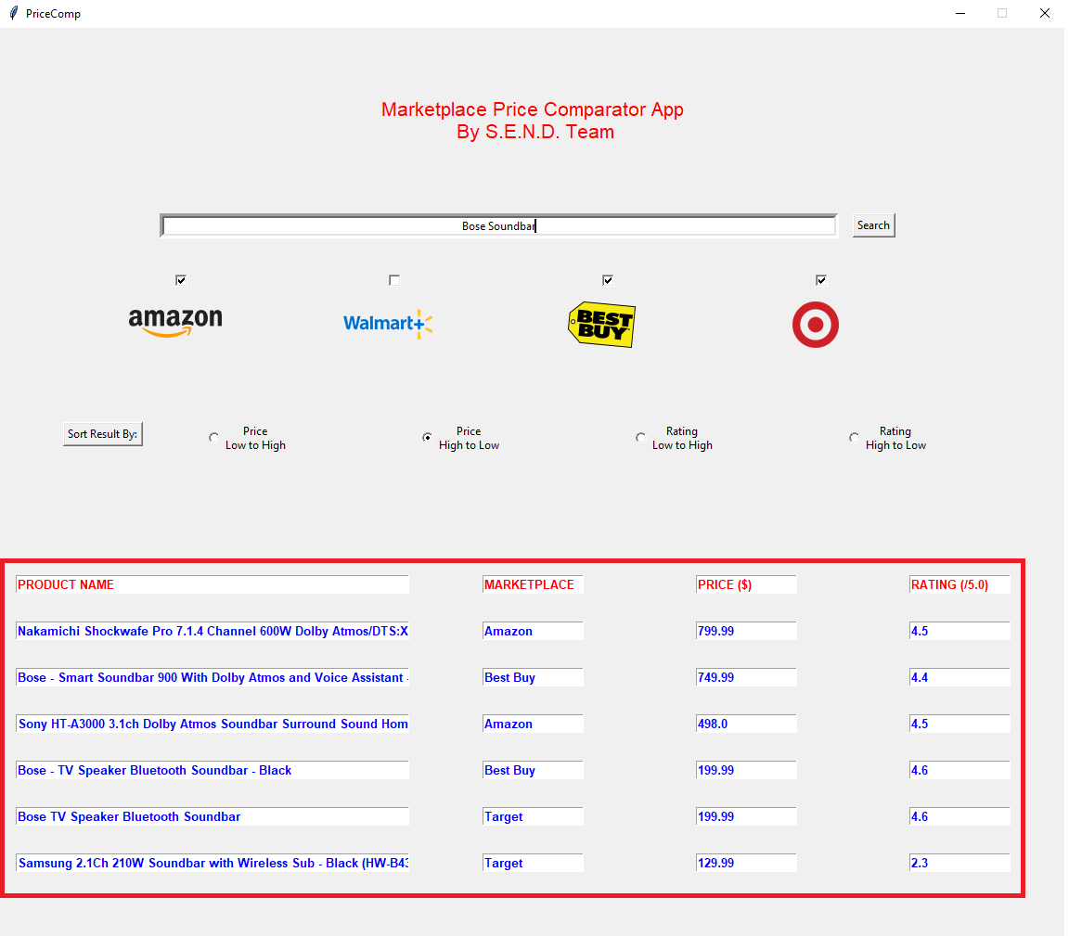

Main Scenario
Purpose:
The main use of the PriceComp app is to provide a single source platform that searches a product through various marketplace sites and displays product data e.g., price and rating.
User:
The individual who wants to buy a product from an e-commerce marketplace but doesn’t want to search it in each individual marketplace but wants to use a platform that can solve the problem in a single click.
Equipment:
The PriceComp app installed on a computer
Scenario:
- User enters the product keyword or SKU# in the search text box which is located on top of the UI window. The keyword can be any combination of alphanumeric characters. The SKU# has to be a legitimate number of the product.
- After the search text is entered, as a next step, the user selects which marketplace sites they want to search the product.
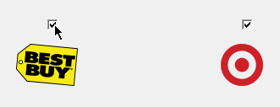
- Once the user selects the marketplace sites, they click on the “Search” button which is located right next to the text box.
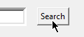
- There will be a pause of a few seconds as the backend code starts searching the product in each selected marketplace site one by one and scrapes the product data.
- Once all the sites are searched and product data are collected, the data is displayed in tabulated form on the bottom of the UI window.
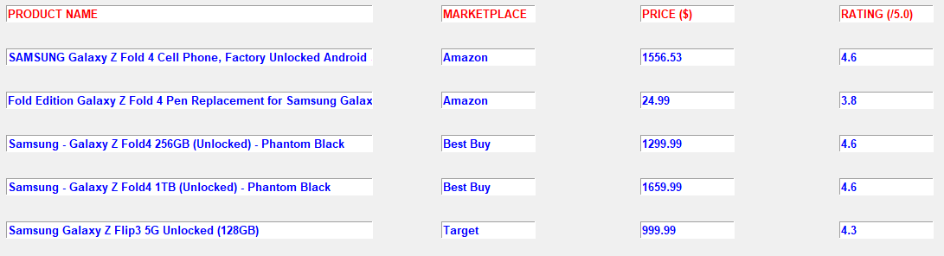
- As an option, user can choose sort by option and clicks on “Sort Result By:” button which will sort the results and again display them in the same tabular form
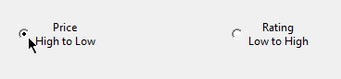

Additional Functionality
PriceCom app is offering the following additional functionality.

Select Marketplace Sites
Our app offers the user the ability to select from four different marketplace sites that they can search for their product: Amazon, Walmart, Best Buy, and Target. The image below outlines how this is laid out in our application. To search a specific market, the user simply needs to check the boxes before the hit “Search”, this will tell the webscraping service which data to provide our UI. 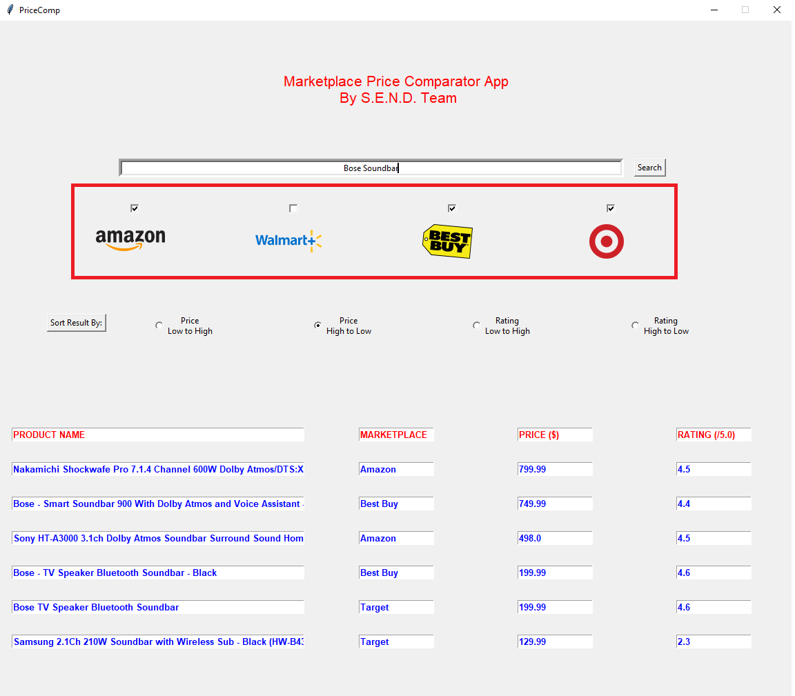
Using this above image as an example, the user is searching the amazon.com, bestbuy.com and target.com marketplaces specifically for a Bose Soundbar. The results will look like the following:

Sort Search Results
The search results that are produced from the user’s selected marketplaces are then passed to our backend, which displays the results in the manner that it finds them. The user may want insight into these products in a way that isn’t visible through the initial results, so a Sort function was added to our UI. The user can sort by Price Low to High, Price High to Low, Rating Low to High, or Rating High to Low. In a similar manner to marketplace selection, the user just selects how they want to sort and click the “Sort Results By” button.
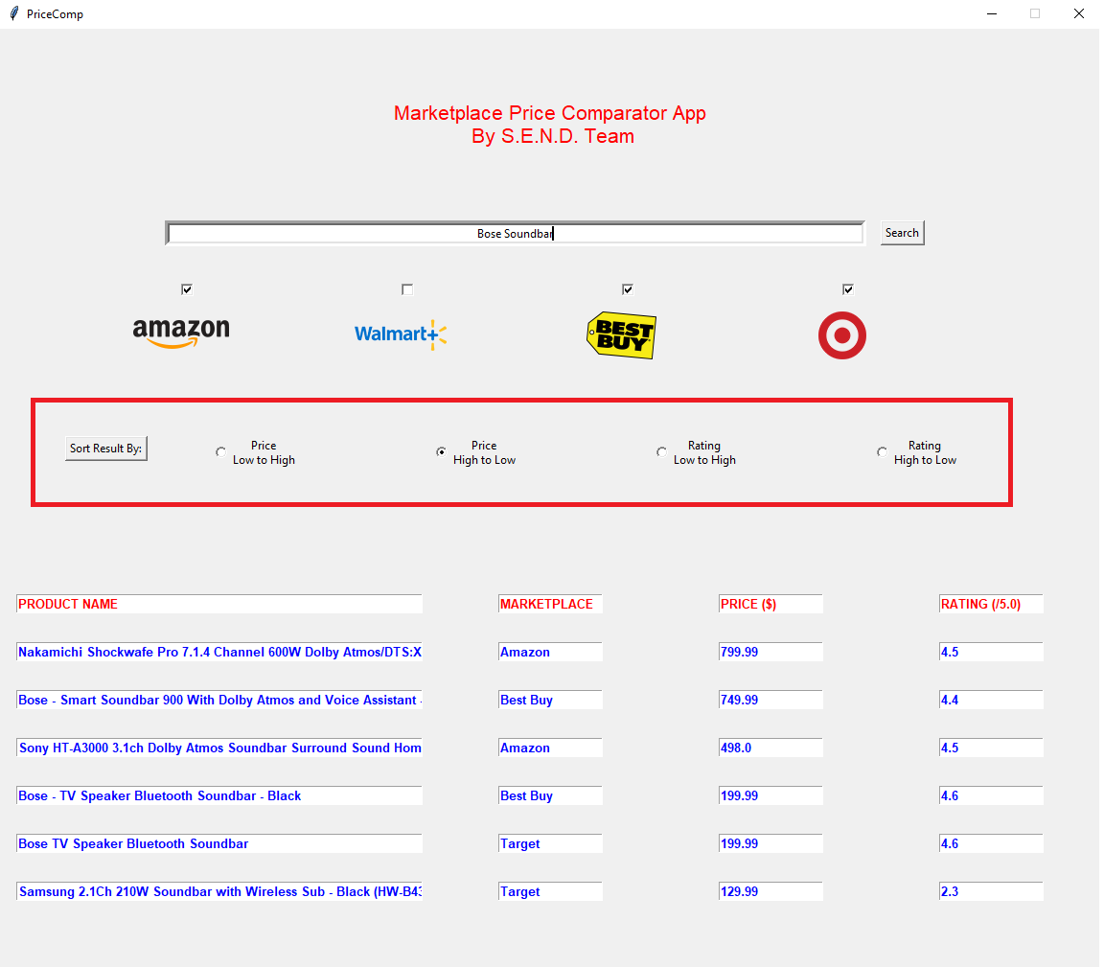
Using this above image as an example, the user is sorting the amazon.com, bestbuy.com and target.com marketplaces specifically for a Bose Soundbar. Using the sort result by “Price High to Low” option, the results are sorted in the backend and the sorted results are displayed on the UI.

Contacts for Troubleshooting
We hope you like the PriceComp app. However, if you encounter any issue while installing or using it, please contact following S.E.N.D. members and we would be happy to help you with troubleshooting your issue.
Nayan Patel (nayanpat@umich.edu)
Steve Anderau (standera@umich.edu)
Ethan Pellegrini (epellegr@umich.edu)
Dheeraj Mohanbabu (dheerajm@umich.edu)

